

**UNITED INTERNATIONAL UNIVERSITY (UIU)**

Dept. of Computer Science & Engineering

Trimester: Fall 2023

Course No: CSE 4495 Title: Software Testing and Quality Assurance

Section: A Class Test-2

**Time: 20 minutes Marks: 20**

|  |  |  |  |
| --- | --- | --- | --- |
| **Name** |  | **ID** |  |

1. You are testing the following method: **[6+6 =12]**

**public double celciusToFahrenheit(double tempInCelcius);**

Devise two executable test cases for this method in the JUnit notation. The test case specifications are described for you –

**/\***case-1 when the input tempInCelcius < 0. The method should work properly for normal negative input temperatures.*/

**/\***case-2 When the input parameter tempInCelcius < -273.16, the method should throw an “ImpossibleValueException” with the following message-‘Input temperature below absolute zero.’ **\*/**

1. Draw the control-flow graph for the following code: **[8]**

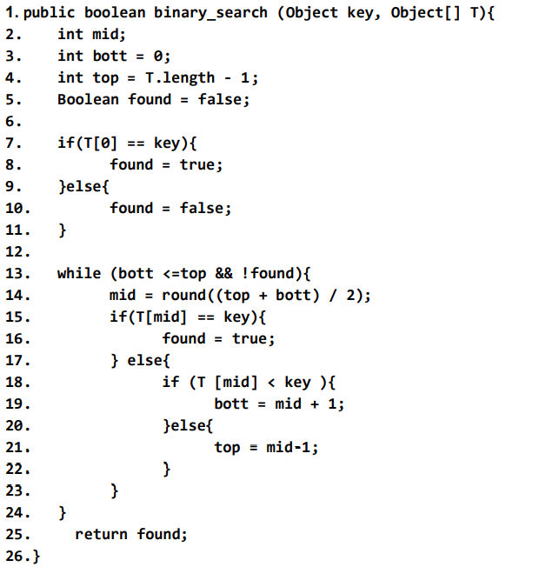

* 1. Draw the CFG for this code.
  2. Show the execution path of the following input.
     1. Binary_search(1, [5,2,1,3])
     2. Binary_search(-1, [-1,])